Real-Time Bengali Sign Language Recognition and Bilingual Text-to-Speech Conversion Using Machine Learning Techniques

Yeastic Hassan Zihan1, Iffaat Ara Mehnaz 2, Anisha Shawana Sharif 3, Nusrat Jahan Tisha 4, Rashedur M. Rahman5

1-5Department of Electrical and Computer Engineering,

North South University.

Plot-15, Block-B, Bashundhara, Dhaka 1229, Bangladesh

yeastic.zihan@northsouth.edu, iffaat.mehnaz@northsouth.edu,

anisha.sharif@northsouth.edu, nusrat.jahantisha@northsouth.edu,

rashedur.rahman@northsouth.edu

**Abstract:** Bengali Sign Language (BdSL) is a vital communication tool for the Deaf community in Bangladesh, relying on hand, facial, and body movements. This research leverages advanced machine learning and deep learning to develop a Real-time BdSL recognition system using a Kaggle-sourced dataset of 1,200 RGB images resized to 128x128 pixels. Six deep learning models were tested, with MobileNetV2 achieving the highest accuracy of 99.89% on training data and 95.85% on testing data. The system provides a practical solution for enhancing accessibility and communication for the Deaf community in Bangladesh. This work is substantially different than the existing work where each sample contains complete sentences, and the research recognizes a specific target at the character level. It includes a bilingual text-to-speech conversion facility. The system converts recognized signs to English and Bengali and widens the accessibility and overcomes language barriers.

**Keywords:**Bengali Sign Language (BdSL); Machine learning (ML); Deep learning models; MobileNetV2; Recognition systems; Overfitting; Training and testing accuracy; Sign language detection.

# **Introduction**

While communication is a key part of every person, millions of people across the globe struggle with it because of hearing impairments. Over 35 million people of Bangladesh use Bengali Sign Language (BdSL) as a medium of communication [1]. Called BdSL, this system of gestures and movements inspired by the sound language of the region allows people with speech and hearing disabilities to articulate complex ideas. But the absence of automated systems for BdSL recognition [2] presents a major issue and hinders accessibility and inclusivity.

This study proposes a novel machine learning based sign language detection (SLD) system using deep learning techniques for the hearing-impaired population to help bridging the communication gap among the society. The aim of the study to accomplish accurate recognition BdSL realizing techniques as One-Hot Encoding, data preprocessing, pretrained networks like MobileNetV2. Our goal is to provide a scalable text to speech (TTS) solution for Bengali and English languages so that we can spread the inclusion and accessibility among the hearing-impaired people of Bangladesh.

1. Literature Review

Real-time Bengali Sign Language (BdSL) identification has evolved as a vital research area that plays a crucial role in breaking communication issues for the deaf/hard-of-hearing people. A plethora of advanced machine learning and deep learning paradigms like convolutional neural networks (CNNs), recurrent neural networks (RNNs) and their hybrid architectures have been explored to improve gesture recognition accuracy [3]. Nonetheless, the challenges of sign language recognition are nontrivial, whereby the high variability in sign language articulation [4], variations in lighting, and the everchanging background environments represent significant hurdles to overcome. Recent studies have been focusing more on the performance of multimodal methods that combine video-based analysis with other sensor data to improve the robustness and generalization of the recognition systems [5]. In spite of the advances in methodology, challenges still remain in the domain, primarily in the form of limited rich, annotated dataset coverage in BSL, the complexity of the phonetic interactions across Bengali (and BSL) that cause recognition tasks to become even more difficult. Future directions revolve around building more diverse and complete datasets, designing context-aware models and developing compact architectures suitable for real-time applications. Resolving these complex challenges is critical to advance the creation of scalable, low-cost [6], and contextually robust BSL detection systems.

1. **Existing Research**

The population with hearing and speech impairments are unable to use the vocal or auditory spoken languages. To make matters worse, there is also a significant diversity in the composition and variations of sign languages across the globe, as they differ significantly from nation to nation. Around 300 unique sign languages are used on the planet, among others American Sign Language (ASL), Japanese Sign Language [7], Chinese Sign Language, French Sign Language, Spanish Sign Language, Bangladeshi Sign Language (BdSL) [8]. Among these ASL has been the most widely studied and best studied linguistically. Learning sign languages is a difficult task for hearing impaired people as well as non-impaired population, and this difficulty is more prevalent in Bangladesh [9], where BdSL is mostly considered as an inherent difficult one. And thus, individuals with hearing and speech impairments are so far away from mainstream society because of such communication barriers.

Sign language recognition is an innovative idea that has been around for a few decades but has recently gained attention in the modern world along with the development of computer vision. Since it is impractical to always have human interpreters available, scientists and researchers are increasingly focused on creating automated systems that are able to accurately detect sign languages. Sign language recognition is a complex task by nature, so researchers tried many approaches, such as SVM [10], HMM, KNN, ANN, and especially CNN [11]. Among them, CNNs have been the most mainstream because they can extract very complex features from image and video data. Therefore, they are very suitable for image processing tasks such as sign language recognition [12]. However, BdSL research efforts are still relatively modest in regard to breadth and magnitude. The linguistic complexity of BdSL, with 38 symbols (9 vowels and 27 consonants), is one of the main challenges that come with it, adding extra layers of complexity [13]. Although some high-profile studies have focused on BdSL, the amount of research remains considerably smaller than for other, better-researched sign languages.

# **Proposed System**

In this paper, we propose a BdSL recognition system that concentrates on dataset acquisition, preprocessing, and experimentation on deep learning.

1. **Dataset**

The proposed Bengali Sign Language (BdSL) recognition system, covering key aspects such as dataset acquisition (source, structure, and relevance) and preprocessing methods to optimize data for analysis. It details the implementation of deep learning models, focusing on their design, modifications for BdSL gestures [14], and the supporting hardware infrastructure. The Bengali Sign Language dataset was sourced from Kaggle, where various datasets were included, but we have selected this because no work has been done on this dataset. It represents a meticulously curated collection of 1,200 images, specifically tailored to encapsulate the diverse categories of Bengali sign language signs, with its structure comprising 30 folders, each containing 40 images corresponding to one of the 40 known sign language categories, thereby ensuring equal representation across all classes to facilitate unbiased and equitable model training. **Figure 1** provides some samples from the dataset.

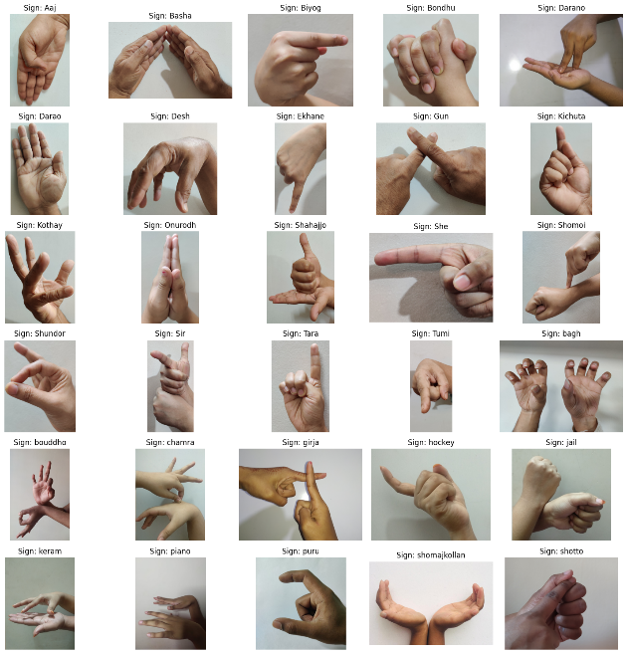

**Figure 1** Full Dataset

1. **Dataset Preprocessing**
2. Resizing Images to same dimensions:

Images are rescaled to 128x128 pixels in the dataset. This process ensures that all the images are of the same size, which is necessary because the deep learning models generally take the inputs of the same size.

1. Normalizing Pixel Values:

The images are represented in a [0,1] pixel space, indirectly meaning that they are initially represented in a 0-to-255-pixel space and divided by 255. This normalization enhances performance of the model in two ways: At the same time, it guarantees faster convergence in the process of training. It also decreases chance of gradient vanishing/exploding problems, ensuring numerical stability, which is especially relevant to optimization methods such as gradient descent.

1. One-Hot Encoding of Labels:

The classes keys (among the 40 BdSL categories) are changed to a one-hot vector. In a multi-class classification problem such as with 40 classes, the label "class 5" is represented through one-hot encoding as an array of the form [0, 0, 0, 0, 1, 0,..., 0]. This format suits the output layer of classification models: the prediction matches one of the 40 classes.

1. Data Augmentation:

For Robustness Various data augmentation techniques are used on the training images, such as to prevent overfitting (performing well on training data but poorly on unseen data).

• Rotate: Rotate the images for hand gesture differences.

• Flipping: Flipping images left and right gives the impression of left-hand and right-hand gestures

• Zoom: Adjusting zoom is done to compensate for the distance difference between the camera and the signer.

These augmentations enhance the variety of the training dataset without necessitating further data collection.

1. Dataset Splitting:

We split the dataset into two sets:

• Training Set: (80%) - Most of the images will be used to train the model

• Testing Set (20%): Consists of the remaining images for testing the model on unseen data.

This participatory separation guarantees that the model is prepared on a bigger example and tried on uncommon and assorted specimens, assisting with evaluating its generalization capacity.

1. **Machine Learning Models**
2. InceptionResNetV2

InceptionResNetV2, a convolutional neural network that seamlessly integrates the strengths of the Inception architecture with the efficiency-enhancing capabilities of residual connections, achieves superior training dynamics and performance optimization through its intricate design, which consists of a sequence of inception blocks meticulously engineered to extract hierarchical features. Pretrained on an extensive corpus of over a million images sourced from the renowned ImageNet dataset, this architecture is inherently well-suited for tackling complex image classification tasks with high degree of accuracy and robustness.

1. MobileNetV2

MobileNetV2, a lightweight convolutional neural network (CNN) architecture specifically designed to cater to the constraints of mobile and embedded vision applications [15], represents a significant advancement over its predecessor, the original MobileNet model, developed by researchers at Google. Distinguished by its remarkable ability to balance model size and accuracy, MobileNetV2 emerges as an optimal choice for devices with limited computational resources, offering an efficient trade-off without compromising performance. Central to the architecture’s efficiency are key design principles, including depth-wise separable convolutions, inverted residuals, bottleneck structures, linear bottlenecks, and squeeze-and-excitation (SE) blocks, all of which collaboratively contribute to minimizing computational complexity while maintaining high levels of accuracy. The deployment of MobileNetV2 for image classification provides substantial advantages, as its lightweight nature facilitates seamless implementation on resource-constrained devices, achieving competitive accuracy relative to larger and more computationally expensive models. Furthermore, its inherent design ensures swift inference times, making it particularly suited for real-time applications, where rapid and accurate processing is paramount.

1. ResNet50V2

ResNet50V2, an advanced iteration of the ResNet framework initially introduced in 2015 by Microsoft Research, is a residual neural network engineered to enable the layers to learn residual functions rather than direct mappings, thereby facilitating the training of exceptionally deep networks. By incorporating skip connections, this architecture effectively mitigates the issue of vanishing gradients, a prevalent challenge in deep neural networks, ensuring stable and efficient learning processes. Comprising a sophisticated structure with 50 layers, ResNet50V2 strikes a balance between computational efficiency and high accuracy, rendering it particularly adept at addressing a wide range of computer vision tasks with remarkable precision and reliability.

1. DenseNet12

DenseNet121, a prominent variant within the Dense Convolutional Network (DenseNet) architecture, epitomizes an advanced deep learning model explicitly tailored for image classification tasks, distinguished by its intricate design comprising 121 interconnected layers. Unlike traditional convolutional neural networks (CNNs) [16] that rely on a sequential connectivity pattern, DenseNet121 introduces a novel approach through densely connected convolutional layers, wherein each layer directly receives input from all preceding layers. This unique connectivity mechanism not only fosters extensive feature reuse but also enhances gradient flow throughout the training process, thereby addressing challenges associated with vanishing gradients and improving overall network efficiency and performance.

1. InceptionV3

Inception V3, a sophisticated member of the Inception family of deep learning models designed for image classification, extends and refines the foundational framework established by its predecessor, Inception V2, incorporating a series of advanced features that enhance its training dynamics and overall performance. Among these features, label smoothing stands out as a pivotal innovation aimed at improving the model's generalization capabilities by mitigating overfitting during the training phase. The architecture itself employs intricately designed arrangements of convolutional layers, orchestrated to capture and learn highly complex patterns within visual data, achieving this with an elevated level of efficiency compared to traditional approaches.

1. Xception

Xception is based on a Google developed computer vision model that is an extreme version of a form of Inception architecture [17]. The former makes it a depth-separable convolution, which has proven to significantly speed up the performance of the model while it as of previous relatives still depends on the regular convolutions of its classic ancestors. This architecture intends to raise the performance of deep networks regarding image recognition problems.

|  |  |
| --- | --- |
| Model Name | Description |
| |  | | --- | |  |   InceptionResNetV2 | Efficient deep feature learning with Inception modules and residual connections |
| MobileNetV2 | A lightweight Mobile-optimized architecture Perfect for resource-constrained environments |
| ResNet50V2 | A residual network to alleviate the vanishing gradient in training deeper models. |
| DenseNet121 | Employs dense connections to improve feature propagation whilst reduce redundancy. |
| InceptionV3 | Its low computational cost and high accuracy is designed in a modular architecture. |
| *Xception* | *A much more complex form of Inception employing depth wise separable convolutions to introduce better spatial feature capturing.* |

**Table 1** Corpora of Pre-trained Model

**Table 1** shows the characteristics of the models.

1. **Evaluation Metrics**
2. Exact Match

A metric which is concerned with the proportion of answers that exactly match the ground-truth answer. EM is a 0/1 metric, which returns 1 if the predicted answer matches the ground truth exactly otherwise its 0.

$$\begin{aligned}EM=\frac{Number of Exact Predictions}{Total Number of Predictions}\#\left(1\right)\end{aligned}$$

1. Precision

Precision is the ratio of accurately anticipated positive observations to the total predicted positive observations. It evaluates the precision of the identified positives.

$$\begin{aligned}Precision=\frac{TP}{TP+FP}\#\left(2\right)\end{aligned}$$

1. Recall

Recall (also known as Sensitivity or True Positive Rate) is an indication of how well the model recognizes positive samples.

$$\begin{aligned}Recall=\frac{TP}{TP+FN}\#\left(3\right)\end{aligned}$$

1. F1 Score & Macro F1-Score

The F1-score is a measure that combines precision and recall into a single number, and is especially useful for assessing model performance when there are imbalances in false positives and false negatives.

$$\begin{aligned}F1=2.\frac{Precision . Recall}{Precision+Recall}\#\left(4\right)\end{aligned}$$

1. Macro F1-Score

It just means the average F1 across all classes, without taking the size of the class into account, so all classes are treated equally regardless of their size.

$$\begin{aligned}Macro F1 Score=\frac{\sum_{i=1}^{n}{F1 Score}}{n}\#\left(5\right)\end{aligned}$$

1. Accuracy

Accuracy is a statistic of the machine learning model that assesses the frequency of correct predictions made by the model. Accuracy is determined by dividing the count of correct predictions by the overall count of forecasts. In other words, accuracy is a statistic that addresses the question: how frequently does the model produce correct results?

$$\begin{aligned}Accuracy=\frac{TP+TN}{TP+FP+FN+TN}\#\left(6\right)\end{aligned}$$

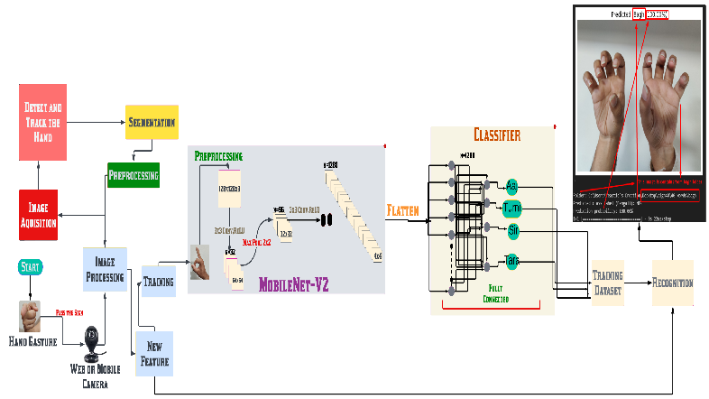

**Figure 2** System diagram

**Figure 2** shows how we train and test our model to predict the Bangla sign. After a successful training we have test a sign where it predicts it or not. And it can predict that sign appropriately and show the outcomes.

Image acquisition is the first step, where the hand movement images are captured by a mobile camera or webcam. Therefore, the online image processing is used for the captured data, where the hand is detected and tracked so that the system only concentrates on the relevant areas. After detection, segmentation extracts the hand from the background, eliminating noise and other unrelated elements. The cleaned and cracked segmented information is then pre-processed and standardized by techniques like image resizing, normalizing, and image enhancement for further analysis. A feature extraction module based on the lightweight MobileNetV2 architecture optimized for mobile devices draws on the preprocessed images. MobileNetV2 then passes the input through depth-wise separable convolutions and bottleneck layers which extract features relevant for classifying a hand gesture (i.e., features such as the overall shape and orientation of the hand). It allows for real-time operations, even on low-power devices.

These features are flattened and fed into a classifier (a few fully connected neural network layers). This classifier predicts the gesture classes and it is trained on BdSL gesture data by using features for mapping them to the predicted output. The output is presented in an easy-to-understand format, e.g., labeled text or image, providing the capacity to visually recognize and comprehend BdSL gestures in real-time. While convolutional neural networks do repetitive patterns of convolutions and subsampling to derive features, MobileNetV2 gives the power of separable convolutions to do the same in an efficient manner. This lightweight architecture will crop the images that are around the size of 128x128x3 and identify the main visual attributes of the images through various blocks. Every block will use depth-wise convolution to aggregate spatial information, while pointwise convolution aggregates output channels. This process is repeated several times to extract increasingly abstract representations, and the final features are classified to identify the content. Although simple in design, the MobileNetV2 performs surprisingly well for vision tasks and with a relatively small number of parameters.

This system demonstrates immense potential to empower the Bangladeshi deaf community through ubiquitous communication access and educational inclusivity. Its dual deployment on mobile infrastructure and sophisticated machine learning architecture guarantee on-the-go translation services with reliable precision. By efficiently deciphering expressed concepts and conveyed notions in real time, this breakthrough can substantively reduce societal barriers faced by those with hearing or vocal impediments. Furthermore, asymmetric sentence structures display the capacity for both simplistic and intricate expression, reflecting the richness of human articulation.

1. **Application**

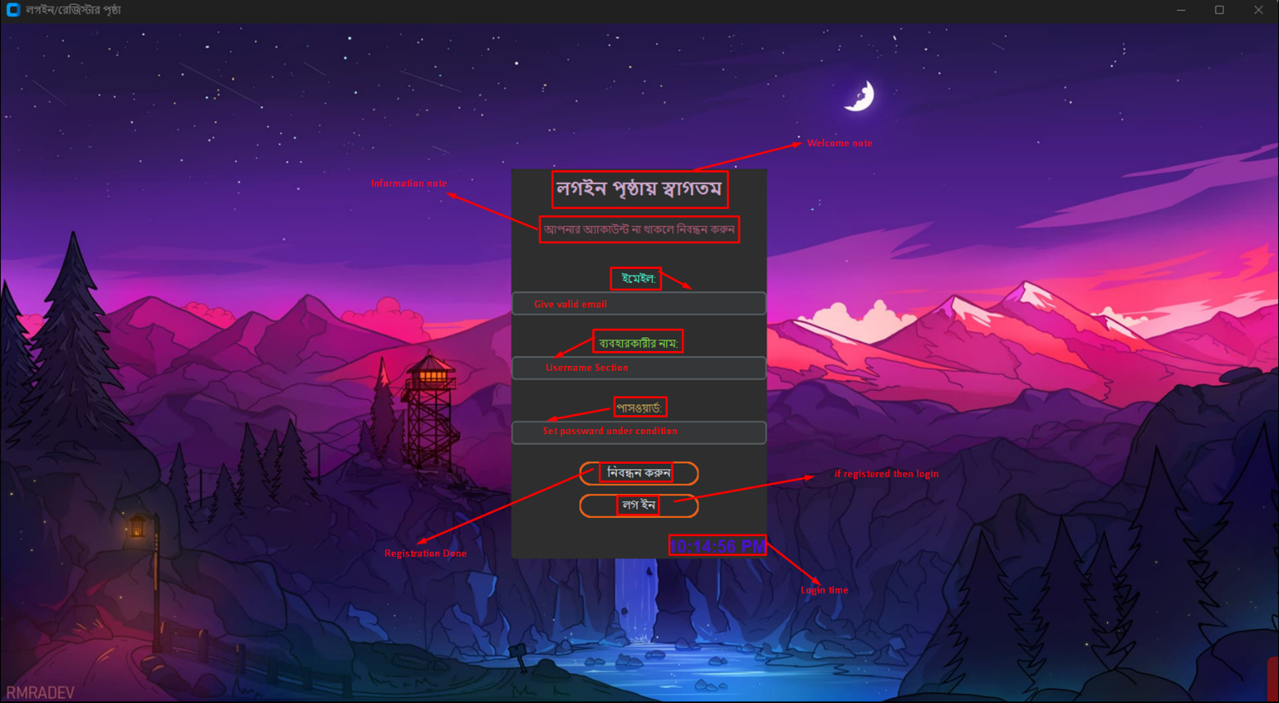

**Figure 3** Login & Register Page

In **Figure 3** we have the login & register page, where we can create a user account by adding valid Email address, Username & password. Then we can create the account there by click the নিবন্ধন করুন (Register) button. After a successful registration we can login in this by adding the username and password. Here, we have also the digital clock to check the login time. ইমেইল (Email): A text box is provided for the user to input their email address. ব্যবহারকারীর নাম (Username): On next another text box for entering the username. পাসওয়ার্ড (Password): A field for the password, likely masked for security. Button is represented: নিবন্ধন করুন (Register): Allows users to create a new account. লগ ইন (Log In): Submits the credentials to log into the application.

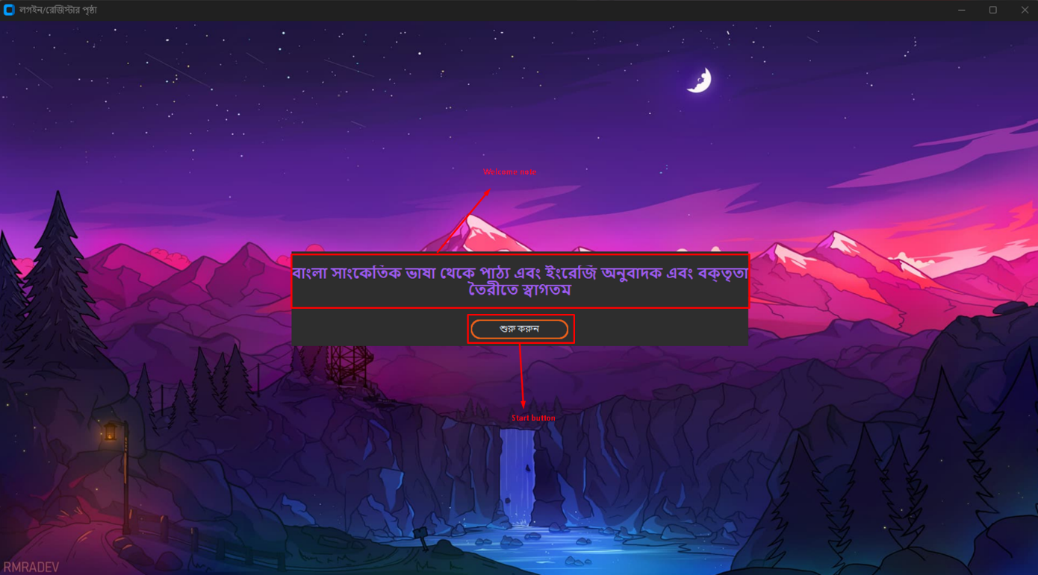

**Figure 4** Welcome page

Bengali Literary language and English translation and audio/speech output are the properties of this App. The welcome message, "বাংলা সাংস্কৃতিক ভাষা থেকে পাঠ্য এবং ইংরেজি অনুবাদক ও বকৃতৃতা তৈরিতে স্বাগতম," means "Welcome to text and English translation and speech generation from Bengali literary language." And added some explain that this literally explain what is the primary functionality of the application. The first button prompts the user through the main features of the app. The simple interface allows any user the ability to take advantage of these features seamlessly in **Figure 4**.

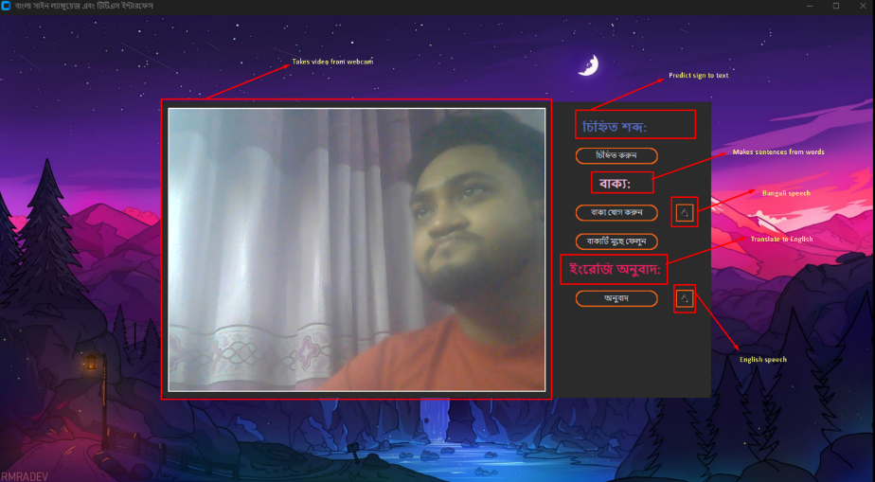

**Figure 5** Main Interface

As we see in **Figure 5**, this is the main interface, here we have the video frame which takes the video from the webcam. This is the most important part of our project. Because without this we cannot predict the sign words. Then we have the function of চিহ্নিত শব্দ (Identified Word) which displays the word corresponding to the recognized gesture. বাক্য (Sentence) Combines multiple recognized words into a coherent sentence by clicking add the word button. We can clear the sentence by clear the sentence button. ইংরেজি অনুবাদ (English Translation) Shows the English translation of the recognized sentence. Takes sentence from the বাক্য (Sentence) and translate it to English, and this happens when the অনুবাদ (translate) button is clicked. This button converts the sentence into speech in Bengali with English also.

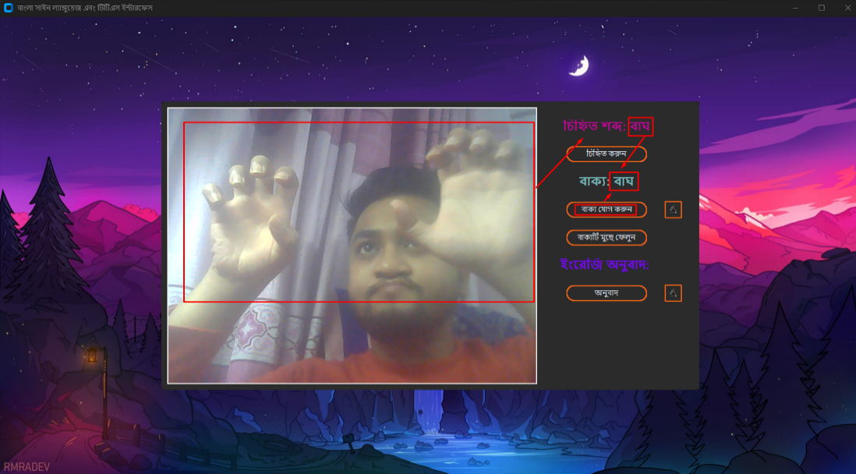

**Figure 6** Prediction of Tiger (বাঘ)

We have discussed earlier about our Main interface in **Figure 5**. So, no need to discuss about the interface. We just discuss about **Figure 6** that shows in this figure. Here the application can predict the sign the word and the বাক্য sentence are take that word also correctly by the button of বাক্য যোগ করুন add the sentence. Updates the বাক্য (Sentence) section with the constructed Bengali sentence.

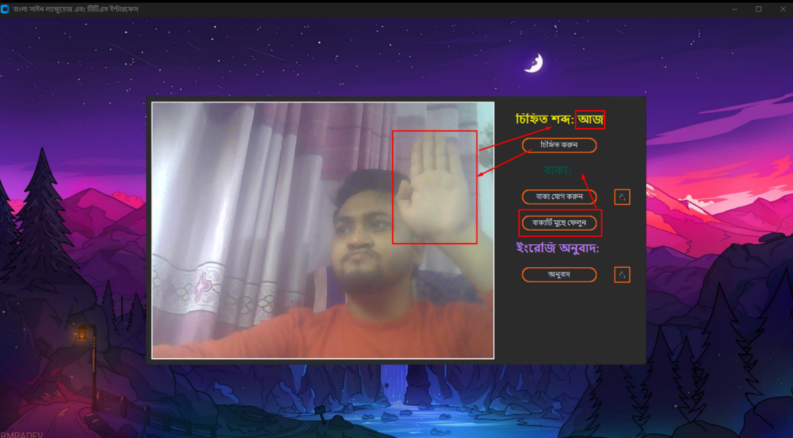

**Figure 7** Working of clear button

This **Figure 7** shows that the function of the বাক্যটি মুছে ফেলুন buttons working.

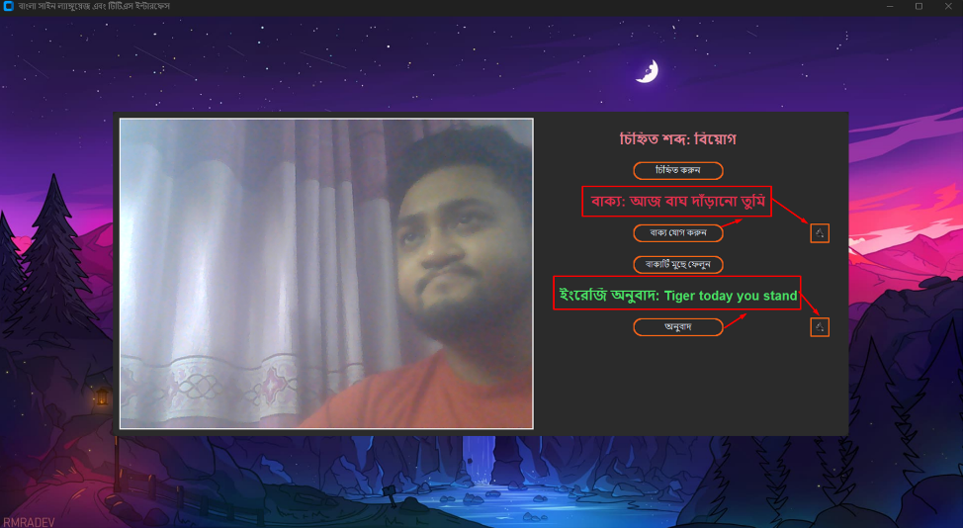

**Figure 8** Sentence Formation of 2-3 words

**Figure 8** contains the sentence formation part. For the lack of image dataset this part is still facing problem to make sentences. বাক্য: আজ বাঘ দাঁড়ানো তুমি This section shows the full sentence being constructed in Bengali by adding recognized words sequentially. বাক্য যোগ করুন (Add Sentence) used to append recognized words to this sentence. অনুবাদ (Translate)this button translates the constructed Bengali sentence into English from the বাক্য (Sentence).

1. **Results & Discussion**

In this section we will show our findings. Here, we have found all the best models by checking different way.

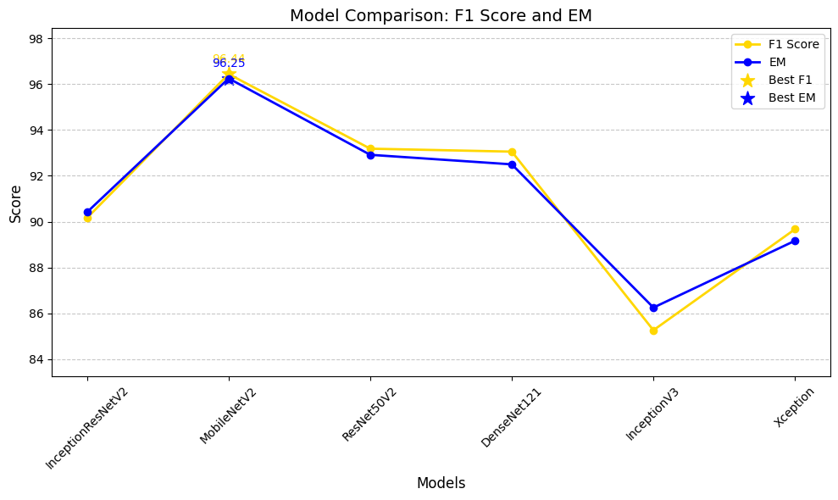

**Figure 9** Best model by F1 Score and EM Comparison

By Comparison of model by F1 Score and Em in **Figure 9** we have found our best model MobileNetV2. Which EM Score is 96.25 and F1 Score of 96.44.

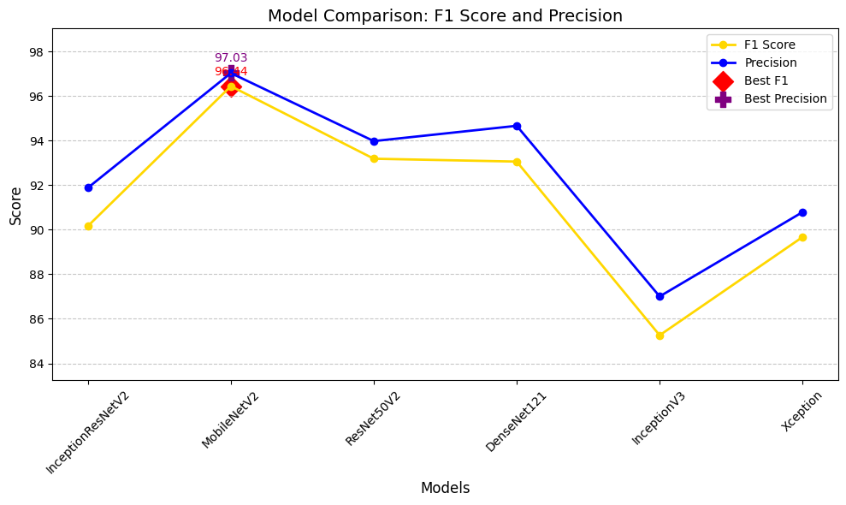

**Figure 10** Model Comparison of F1 Score and Precision

By Comparison of model by F1 Score and Precision in **Figure 10** we have found our best model MobileNetV2. Which Precision Score is 97.03 and F1 Score of 96.44.

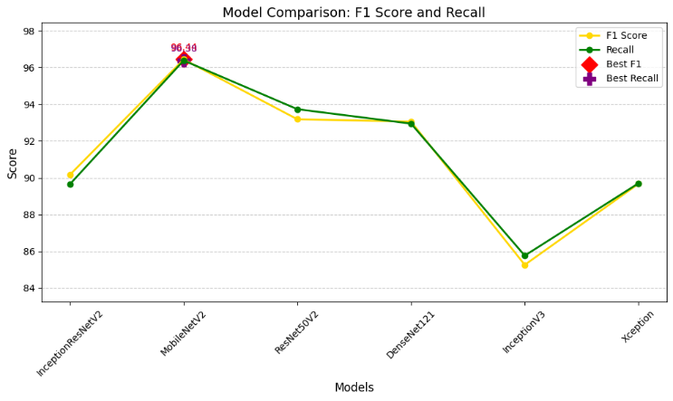

**Figure 11** Model Comparison of F1 Score and Recall

By Comparison of model by F1 Score and Recall in **Figure 11** we have found our best model MobileNetV2. Which Recall Score is 96.38 and F1 Score of 96.44.

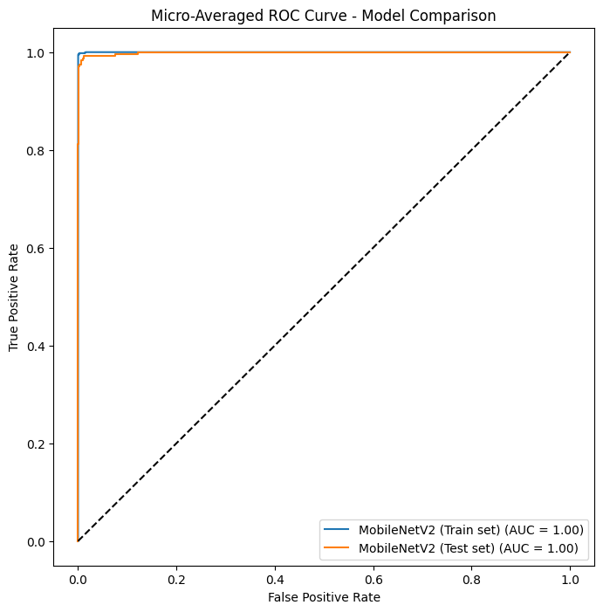

**Figure 12** Model Comparison of Train and Test Set

In **Figure 12** again MovileNetV2 is the best for train and test set the AUC of 1.00.

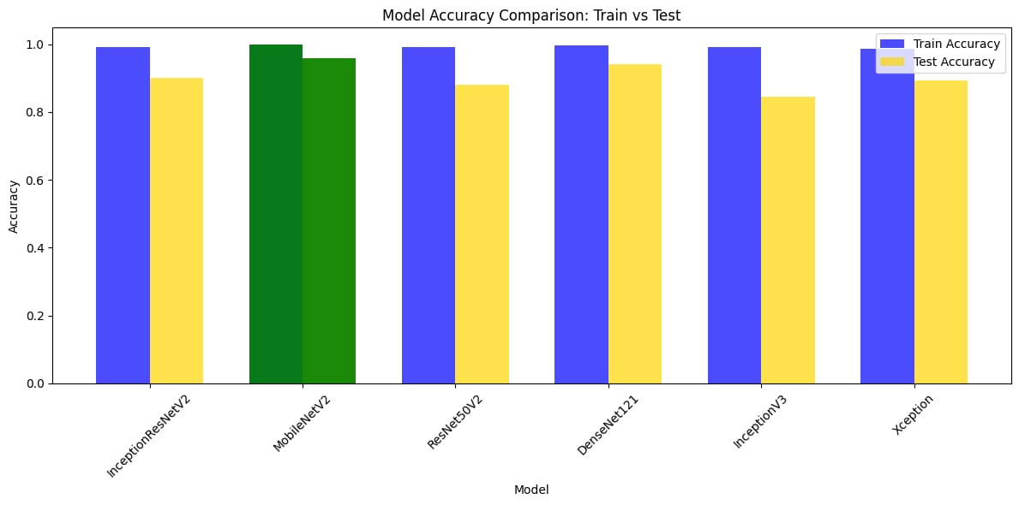

**Figure 13** Model Accuracy Comparison by Train VS Test

This **Figure 13** is about bar chart compares the training and testing accuracy of various deep learning models: InceptionResNetV2, MobileNetV2, ResNet50V2, DenseNet121, InceptionV3, and Xception. The blue bars represent the train accuracy, while the yellow bars represent the test accuracy.

|  |  |  |  |
| --- | --- | --- | --- |
| **Bengali Sign language best model** | | | |
| **Model** | **Epoch** | **F1 Score** | **EM** |
| InceptionResNetV2 | 30 | 0.90 | 0.90 |
| MobileNetV2 | 30 | 0.96 | 0.96 |
| ResNet50V2 | 30 | 0.93 | 0.93 |
| DenseNet121 | 30 | 0.93 | 0.93 |
| InceptionV3 | 30 | 0.86 | 0.85 |
| Xception | 30 | 0.89 | 0.90 |

**Table 2** Select Best model

MobileNetV2 Train Accuracy: 0.9989583492279053, Test Accuracy: 0.9585062265396118, Best Model by F1-Score: MobileNetV2 = 96.17% Best Model by Precision: MobileNetV2 = 96.27%, Best Model by Recall: MobileNetV2 = 96.39% Best Model by Lenient Accuracy: MobileNetV2 = 95.85 as per shown in above **Table 2**.

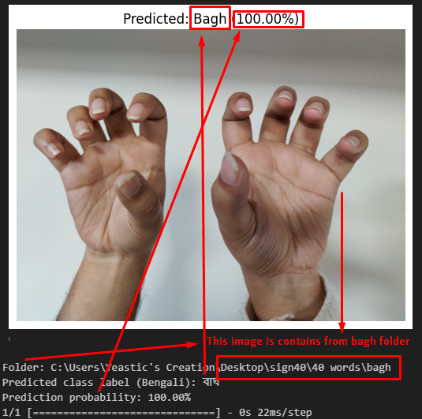

**Figure 14** Predict by MobileNetV2 from the main dataset

In this **Figure 14**, we have found that the model takes the image from the folder from the accurate location of the images of Bagh sign. Then predict it what that sign show is Bagh with the probability of 100%.

The Real-time Bengali Sign Language recognition system [18] has proved its high sensitivity in detecting and classifying complex hand gestures with considerable accuracy and effectiveness, which results in smooth and proper communication for everyone. It is working-bilingual elegance, as it renders nuances of gesture into Bengali flow-text, and then English text via speech synthesis with pitch modulation, makes it incredibly useful for complex cross-lingual interactions across inter-lingual barriers with each partner. The clever way the system is able to create 2–3 word phrases, meaningful yet changeable, swaps this input to any number of combinations, offers the possibility of much more complex communication. The interface has a well-crafted login/registration page, a layout which allow us to explore, and a one-click to select prompt, only enhances the accessibility and useability of the advanced application for everybody.

But despite advances, some intimidating barriers impede the full scope of the system. Environmental dependencies, including low light conditions, cluttered backgrounds [19], and diverse user postures, lead to decreased gesture recognition performance. The requirement for a bystander to confirm two-handed movements with the “select” button strips away autonomy and makes it less user-friendly. Latency on-real time working prevents exchanges from being smooth, the limited training data limits the generalization of the model. On top of this, the graphics in the interface are also flat. However, text-to-speech output often does not produce natural and contextually appropriate speech, particularly in Bengali, resulting in belief and satisfaction of users diminished.

1. Conclusion

This paper presents a novel approach to real-time Bengali Sign Language (BdSL) recognition [20], that is a manipulation of BdSL gestures alongside the text-to-speech conversion and Bengali-English translation integrated in the text output that meets the basic needs of accessibility for the Deaf as facing complication in everyday communication. Real-time gesture detection is ensured using a complex framework of Bengali Sign Language (BdSL) for dynamic input processing and categorization, and providing seamless interaction. The system improves its communication capabilities by identifying gesture patterns which correspond to multiple words (typically two to three) and composing sentences. This enables the construction of self-contained micro-phrases which enhance real-time communication. A full-fledged advanced pipeline implemented in the text conversion procedure of the real-time gesture recognition system receiving commands of recognized motions and providing a synchronized interactive experience for a seamless multilingual dialogue. Then, after successfully transforming Bengali gestures, motion and movement of fingers and hands into textual format (for the most part in English), the system passes the generated text to an integrated text to speech (TTS) engine, which produces the audio. There is minimal research on Bengali Sign Language that covers most of what we need to know.

**References**

|  |  |
| --- | --- |
| [1] | S. K. Akash, D. Chakraborty, M. M. Kaushik, B. S. Babu and M. S. R. Zishan, "Action Recognition Based Real-time Bangla Sign Language Detection and Sentence Formation," in *2023 3rd International Conference on Robotics, Electrical and Signal Processing Techniques (ICREST)*, Dhaka, 2023. |
| [2] | B. C. Karmokar, K. M. R. Alam and M. K. Siddiquee, "Bangladeshi Sign Language Recognition employing Neural Network Ensemble," *International Journal of Computer Applications,* vol. 58, no. 16, pp. 0975-8887, 2012. |
| [3] | A. Haque, R. A. Pulok, M. M. Rahman, S. Akter, N. Khan and S. Haque, "Recognition of Bangladeshi Sign Language (BdSL) Words using Deep Convolutional Neural Networks (DCNNs)," *Emerging Science Journal,* vol. 7, no. 6, pp. 2183-2201, 2023. |
| [4] | N. Begum, R. Rahman, N. Jahan, S. S. Khan, T. Helaly, A. Haque and N. khatun, "A Real-Time Bengali Sign-Character Detection and Sentence Generation System Using Quantized Yolov4-Tiny and LSTMs," *Applied Science,* vol. 13, no. 9, p. 5219, 2023. |
| [5] | N. N. Choudhury, G. Kayas and D. M. Khan, "Automatic Recognition of Bangla Sign Language," BRAC University, Dhaka, 2012. |
| [6] | S. A. Shurid, D. Karmaker, M. G. R. Alam, K. H. Amin, M. T. Mahtab, M. A. Alam, M. S. Mirbahar and F. T. Khan, "Bangla Sign Language Recognition and Sentence Building Using Deep Learning," in *2020 IEEE Asia-Pacific Conference on Computer Science and Data Engineering (CSDE*, Dhaka, 2020. |
| [7] | M. R. Uddin, "Creating Multiclass Bangladeshi Sign Word Language for Deaf and Hard of Hearing People and Recognizing using Deep CNN Techniques," University of Information Technology and Sciences (UITS), Dhaka, 2024. |
| [8] | S. Siddique, S. Islam, E. E. Neon, T. Sabbir, I. T. Naheen and R. Khan, "Deep Learning-based Bangla Sign Language Detection with an Edge Device," *Intelligent Systems with Applications,* vol. 18, no. 200224, pp. 1-12, 2023. |
| [9] | M. S. Islam, M. M. Rahman, M. H. Rahman, M. Arifuzzaman, R. Sassi and M. Aktaruzzaman, "Recognition Bangla Sign Language using Convolutional Neural Network," in *2020 23rd International Conference of Computer and Information Technology (ICCIT)*, Kustia, 2019. |
| [10] | H. A. Rubaiyeat, H. Mahmud, A. Habib and M. K. Hasan, "BdSLW60: A Word-Level Bangla SIgn Language Dataset", Dhaka: 10.13140/RG.2.2.12193.79202, 2024/02/14. |
| [11] | D. Talukder and F. Jahara , "Real-Time Bangla Sign Language Detection with Sentences and Speech Generation," in *2020 23rd International Conference of Computer and Information Technology (ICCIT)*, Chittagong, 2021. |
| [12] | M. W. Foysol, S. E. A. Sajal and M. J. Alam, "Vision-based Real-Time Bangla Sign Language Recognition System Using MediaPipe Holistic and LSTM," Daffodil International University, Dhaka, 2023. |
| [13] | T. Abedin , A. Moshruba, K. S. Prottoy and S. B. Hakim, "Bangla Sign Language Recognition Using Concatenated BdSL Network", Dhaka: 10.48550/arXiv.2107.11818, 2021/07/25. |
| [14] | R. H. Pranto and S. Siddique, "Real-time Bangla Sign Language Translator", Dhaka: 10.48550/arXiv.2412.16497, 2024/12/21. |
| [15] | N. Malik and N. Walia, "ML-BASED HAND SIGN DETECTION SYSTEM FOR DEAF-MUTE PEOPLE," *International Journal of Advance and Innovative Research ISSN: 2394-7780,* vol. 09, no. 02, pp. 43-48, 2022. |
| [16] | A. Pathak, A. Kumar, Priyam, P. Gupta and G. Chugh, "Real Time Sign Language Detection," *International Journal for Modern Trends in Science and Technology,* vol. 8, no. 01, pp. 32-37, 2022. |
| [17] | A. Hasib, S. S. Khan, J. F. Eva, M. N. Khatun, A. Haque, N. Shahrin, R. Rahman, H. Murad, M. R. Islam and M. R. Hussein, "A Comprehensive Dataset of Bangla Sign Language," *Elsevier,* vol. 49, pp. 2-8, 2023. |
| [18] | H. Mural, S. F. Faisal and S. C. Banik, "Real Time Bangla Sign Language Detection Using Action Recognition," Chittagong University of Engineering and Technology, Chittagong, 2024. |
| [19] | O. B. Hoque, M. I. Jubair, M. S. Islam, A. F. Akash and A. S. Paulson, "Real Time Bangladeshi Sign Language Detection Using Faster R-CNN", Dhaka: 10.48550/arXiv.1811.12813, 2018/11/30. |
| [20] | G. S. Surjo, B. K. Ghosh, M. J. Alam, Mahamudullah, M. Razib and S. Bilgaiyan, "A comparative analysis between single & dual-handed Bangladeshi Sign Language Detection using CNN based Approach," in *2023 International Conference on Computer Communication and Informatics (ICCCI-2023)*, India, 2023. |